# Readme for Windows

1. Save Gro: Save the GRO Folder in a Folder of your choice.
2. Open Gro: Look for the gro.exe file places in the WIN-Executable/GRO/release Folder and open it.
   1. It is recommended to create a shortcut of this file and place it in the desktop. You even can change the icon to the one in the GRO/release Folder called groicon.ico.
3. Working directory: Once gro.exe is clicked the main gro window will pop out. The working directory will be specified on the bottom of the window (See image). This working directory will be needed in the next step.

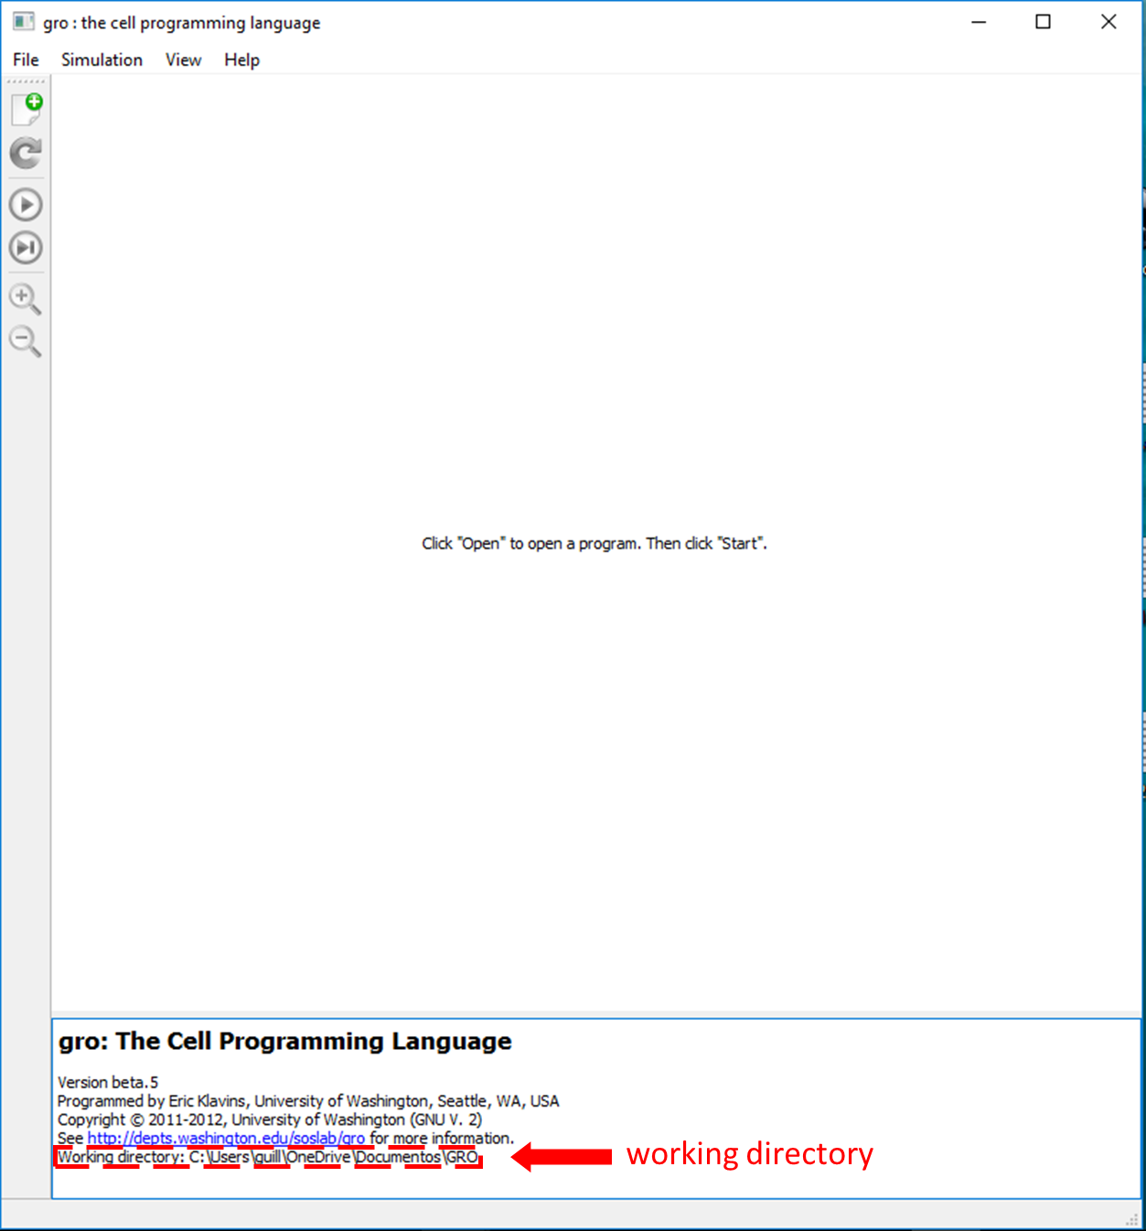

1. Copy the GRO libraries into the working directory: Copy both libraries standard.gro and gro.gro into the working directory. These two files are found in the GRO Folder. It is highly possible that this is already your working directory. If so, there is nothing to do.

Now gro is correctly installed in your computer. You are ready to execute gro.exe and run some experiment. Visit www.lia.upm.es for manuals and examples.